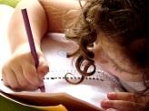  Literacy and WCR  In Talk 4 Writing, this half term, Year 3 will be exploring the genre of a defeating a monster story. We will be writing our own defeat a monster story focusing on the key literary devices to help set the scene and build the tension. We will then be writing instructions on how to catch a monster.  Year 3 will be reading “The Abominables” from Pie Corbett’s reading spine. | Maths  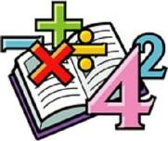  In Maths, we will continue looking at addition and subtraction before we then move on to multiplication and division.  We will continue to develop our arithmetic skills to which we can apply to help us solve problems.  We will continue to complete daily times tables practise. | Science  In Science, this half-term, we will be looking into the topic “Forces”  This includes looking at contact and non-contact forces. We will be conducting experiments and reflecting upon them through conclusions. | Computing  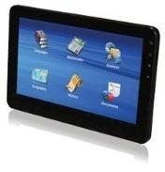  In Computing, Year 3 will be exploring the world of animation through Scratch. We will be programming a story/game using coding to explore different aspects of programming.
Humanities  In Geography, Year 3 will be looking where we live, our local counties, our country and the continent we live in. We will be discussing nearby countries in the continent of Europe. | Overdale Community Primary School  Year 3 Autumn 2 – 2023  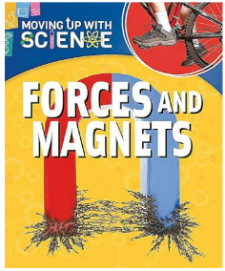  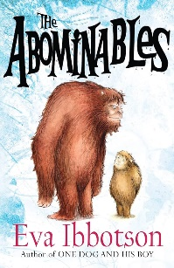 |  | 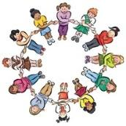  RHE/PSHE  This term in PSHE, Year 3 will be looking at our Health and Well-being.  Year 3 will be sharing how we keep ourselves healthy – physically and mentally. We will look into our own strengths and barriers and work together to understand how we can overcome them.
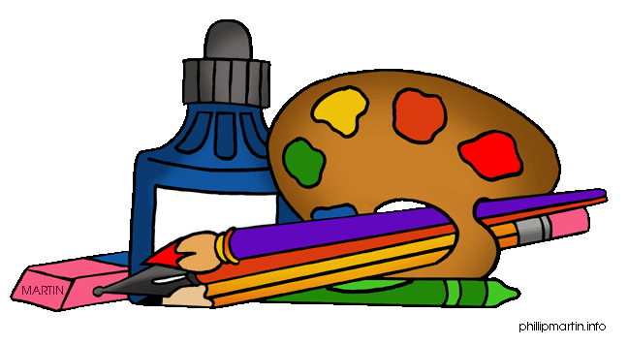  Art and DT  In DT, we will be looking at food and nutrition. Year 3 will look into how certain foods are only available at key points during the year. Year 3 will look at how seasoning can affect food. Finally, Year 3 will be making their own seasonal tart to try and evaluate. | PE  This term in PE, we will be looking at gymnastics and how we spin and balance effectively to create a final performance whilst practising safety and correct techniques. (Mondays)  Year 3 are very fortunate to be receiving hockey coaching from a specialist this half term. (Tuesdays) | French  In French, we will be looking at adjectives and colours. We will be able to describe colours of shapes through a conversation in French.  Music  In Music, Year 3 will be looking at how to create a composition to match a photograph through movements and rhythms to tell a story. | RE  In RE, we will be looking at a key question.  Our key question this half term is:  “What do different people believe about God?”  Muslims and Christians

Reading: Children will be expected to read their home reading books three times a week with a written comment from a parent in their reading record. Books will be changed when children complete a book review of their current reading book or in a phonic session.
Maths: Children will be tested on their times tables throughout the week as well as a weekly arithmetic test to build their mental arithmetic confidence.
Homework: Year 3 have been given homework book with weekly tasks to complete that relate to learning that has been delivered during the week. Year 3 will have a maths task, spelling/handwriting task and a foundation subject task to complete. This is handed out every Friday and is expected to be returned the following Friday.

